

Course Code: CSE110

Course Name: Object-Oriented Programming

Section:20

Semester:Fall 2024

Submitted to

Md.Sabbir Hossain

Department of Computer Science and Engineering

Submitted by

Marzia Hasan

ID: 2024-1-60-213

Submission Date: 25th October 2024

* Class 1

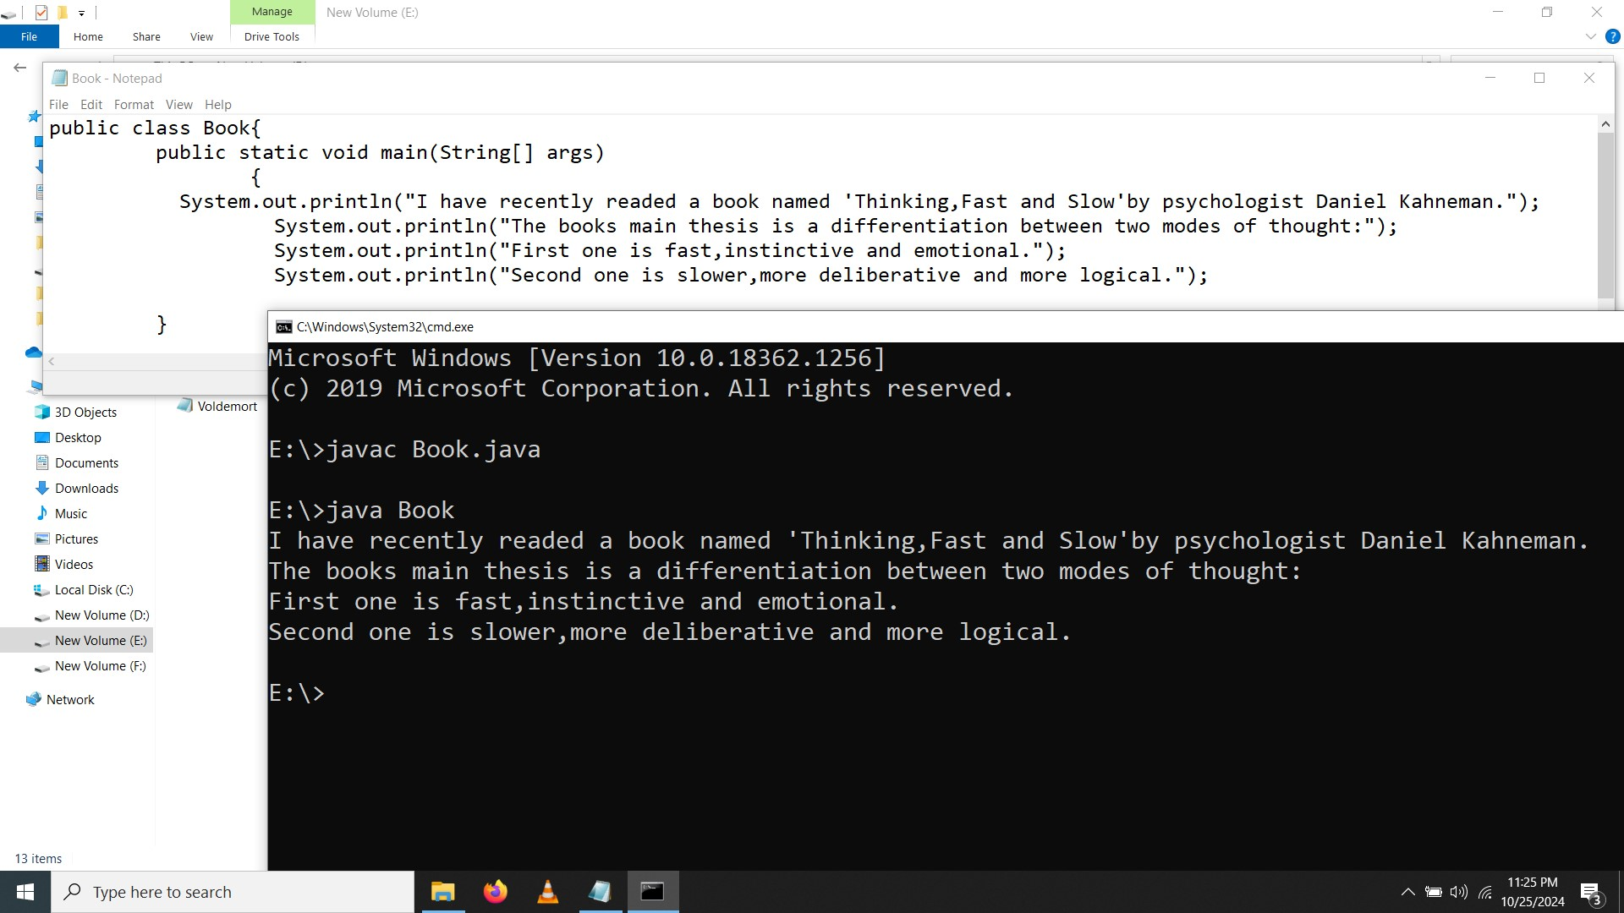

* Class 2

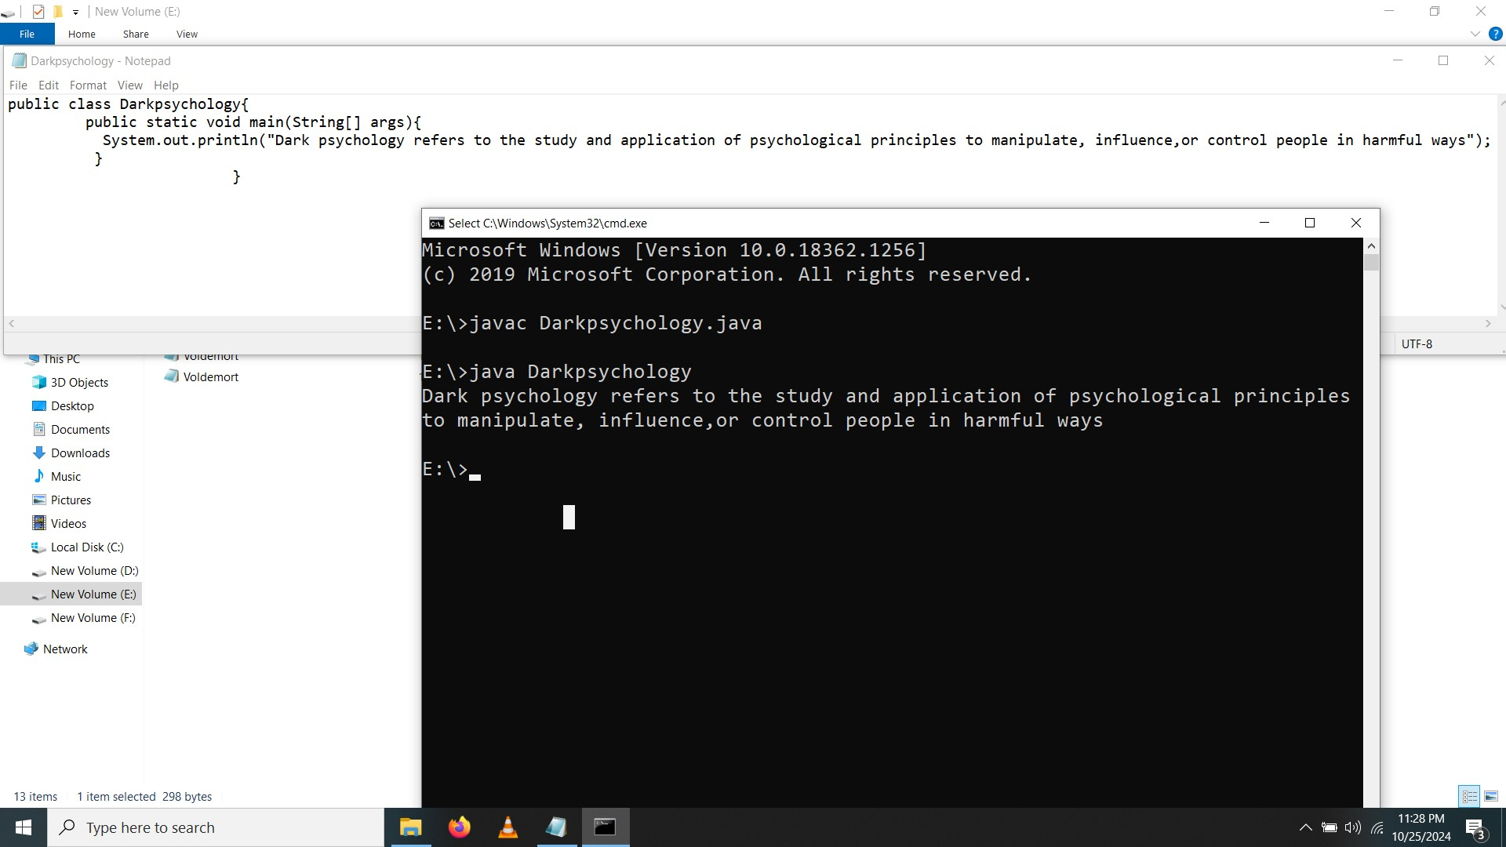

* Class 3

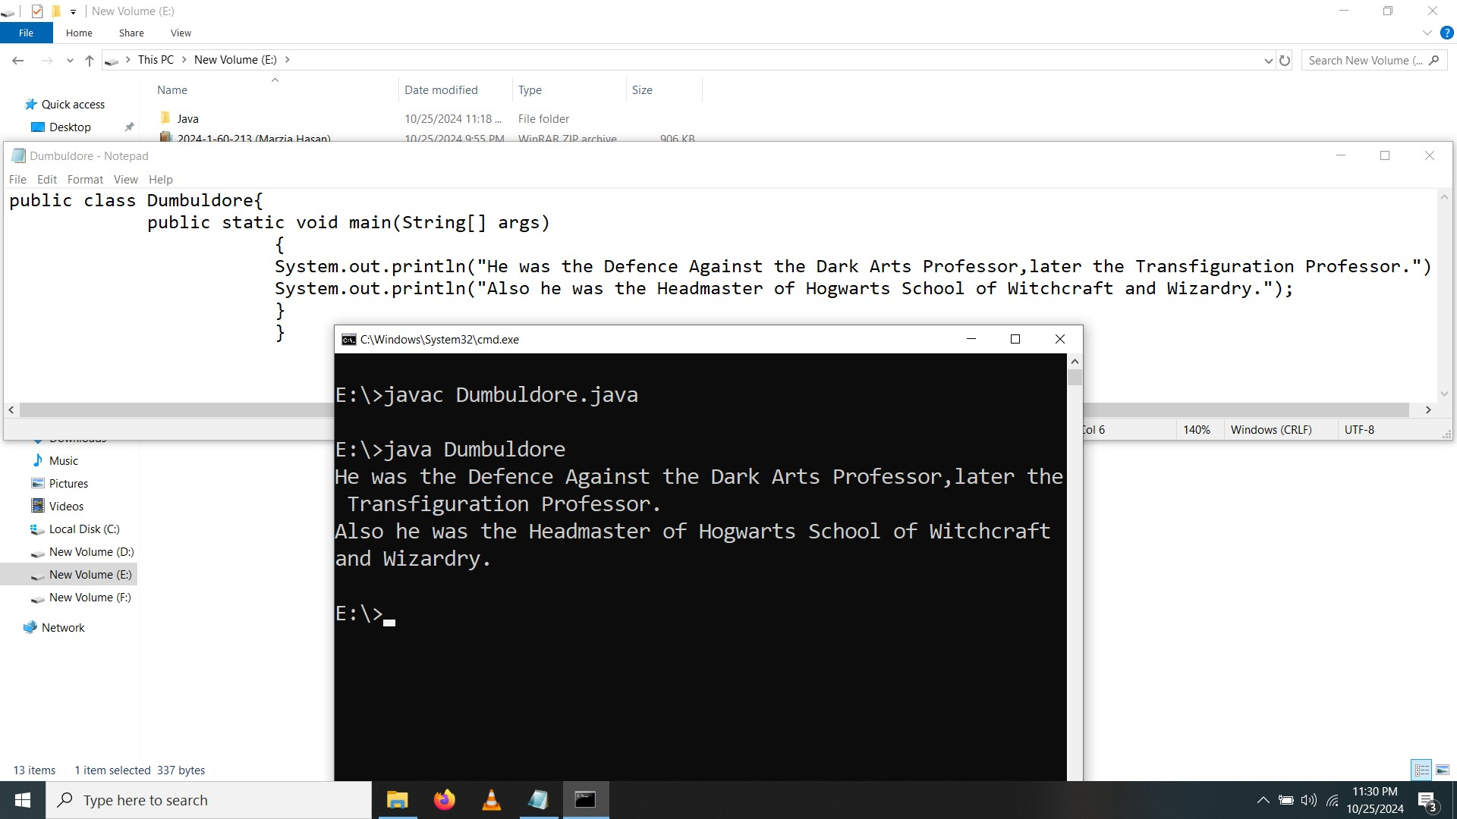

* Class 4

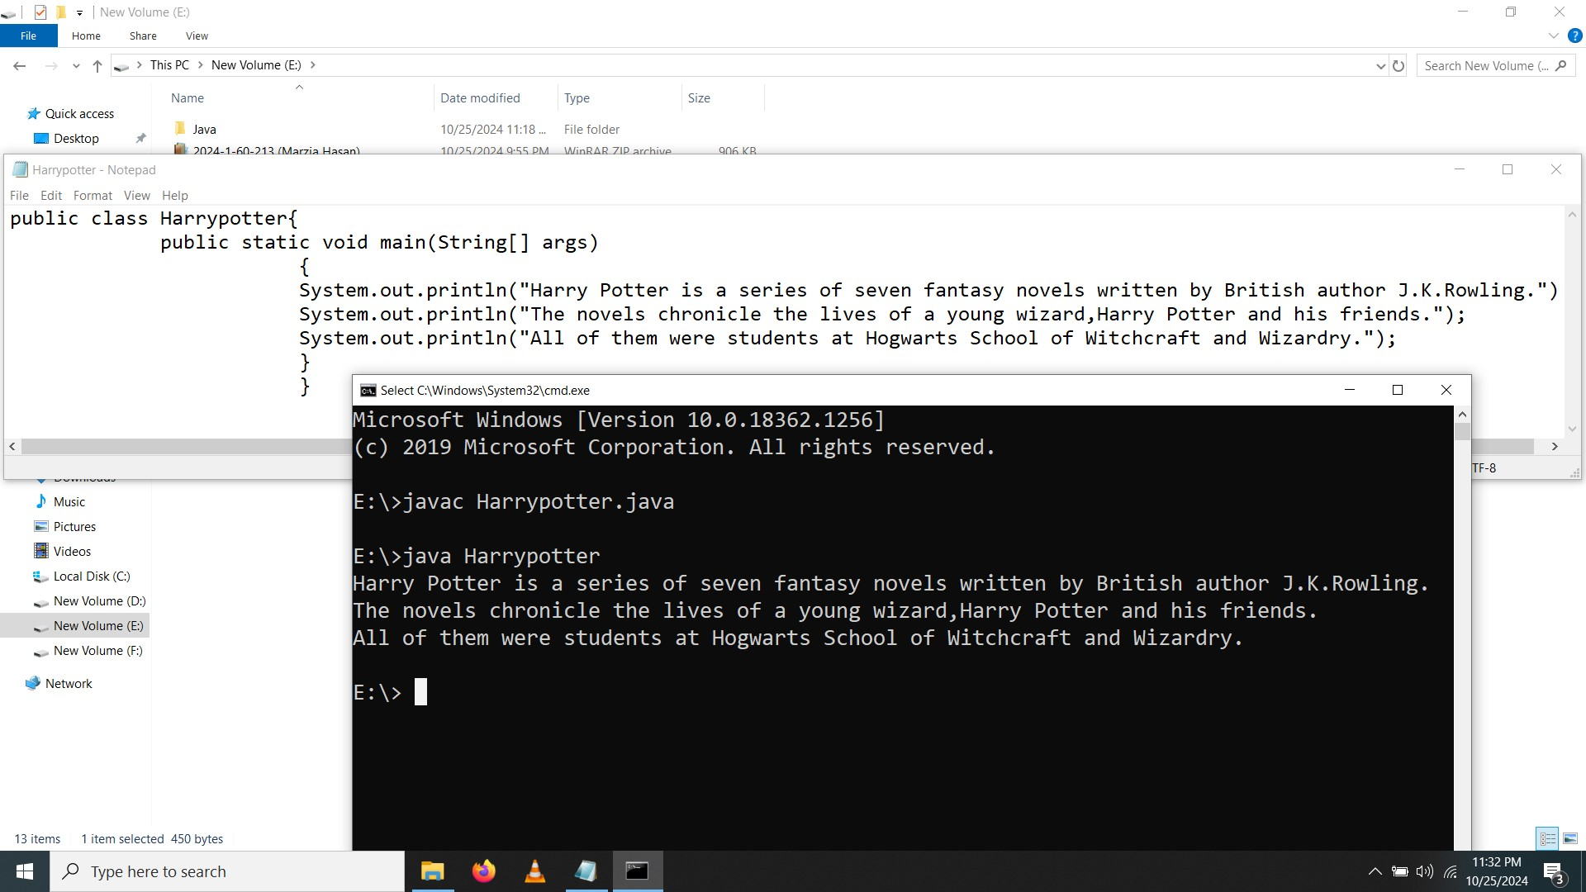

* Class 5

